**DATABASE MANAGEMENT SYSTEMS**

**CS6106**

**PROJECT ABSTRACT**

**TITLE – FLIGHT RESERVATION SYSTEM**

**PREPARED BY: ARSHAK SHAN**

**ROLL NO: 2018103010**

**DEPARTMENT OF COMPUTER SCIENCE AND ENGINEERING**

**FLIGHT TICKET RESERVATION SYSTEM**

Airline reservation system is one of the most used database system in the world. It is an example of Transaction processing systems. **Transaction processing systems** are systems with large databases and hundreds of concurrent users executing database transactions. These systems require high availability and fast response time for hundreds of concurrent users.

We define the concept of a transaction, which is used to represent a logical unit of database processing, that must be completed in its entirety to ensure correct- ness. A transaction is typically implemented by a computer program, which includes database commands such as retrievals, insertions, deletions, and updates.

In this project, we deal with the database part of the whole system with insertions, deletions and updates as the primary task of our system along with maintenance of the integrity of the system at all stages of a transaction.

The system that is being described in this report handles everything that the most practical systems would do. The complexity of the database system has been handled by trying to make most basic entities resembling the real world objects. The database handles the most basic functions of an airline reservation system, including reservation, cancellation and updating of a flight trip transaction.

ER DIAGRAM

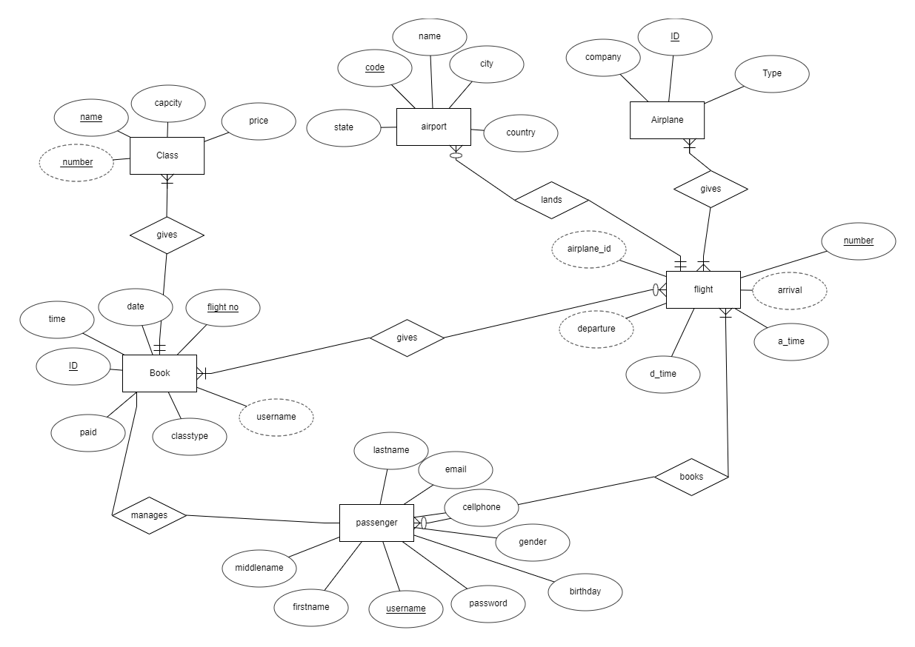

Project Schema

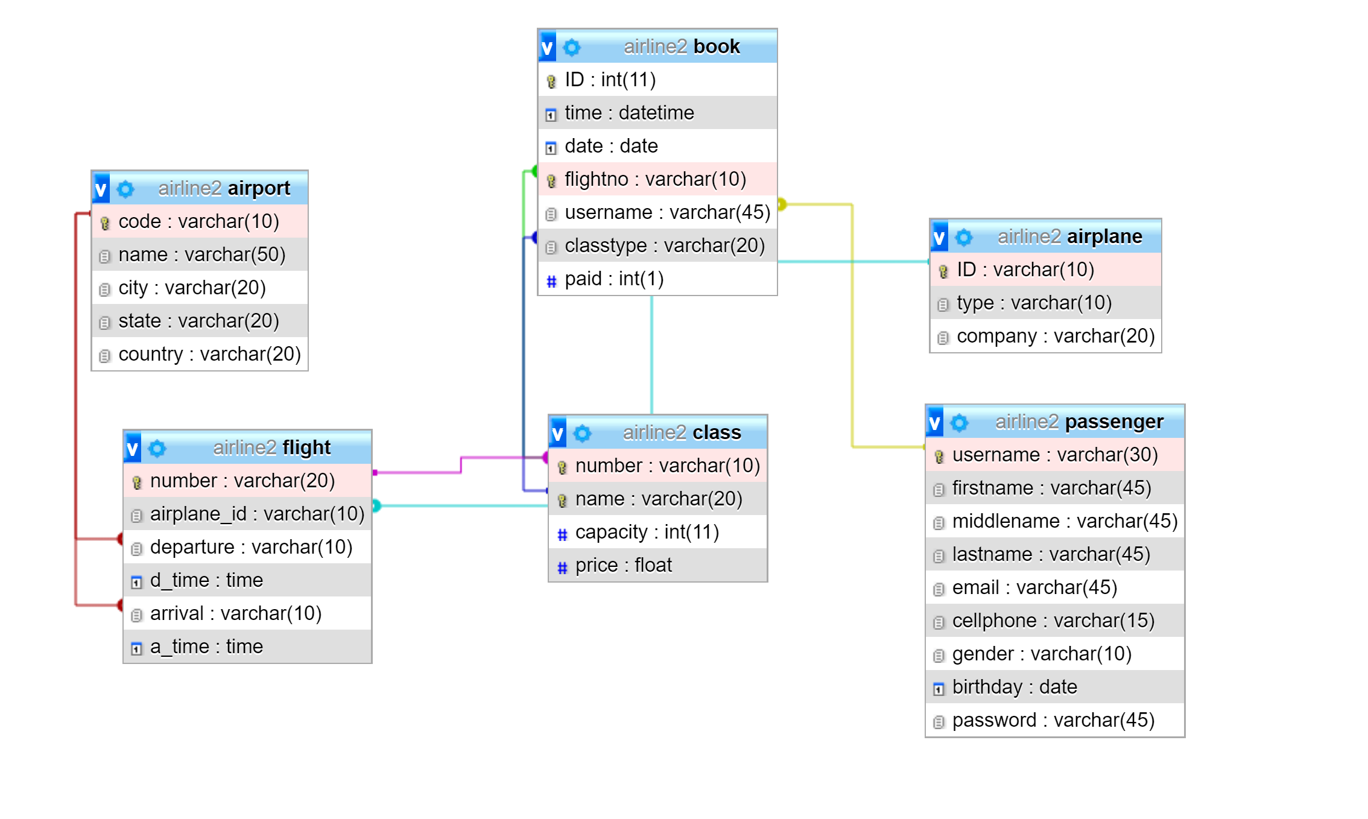

Tables

Airplane:

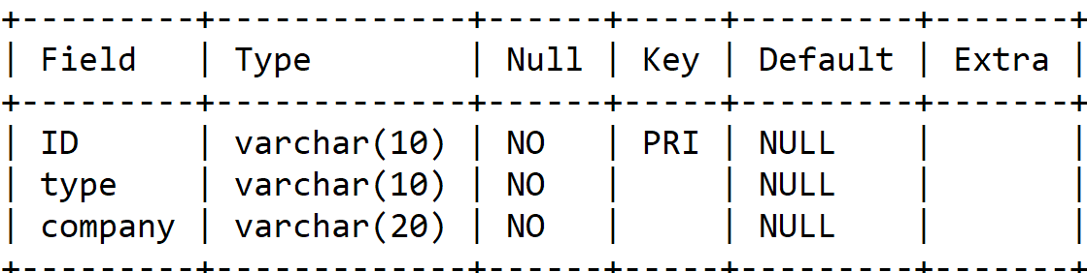

Airport:

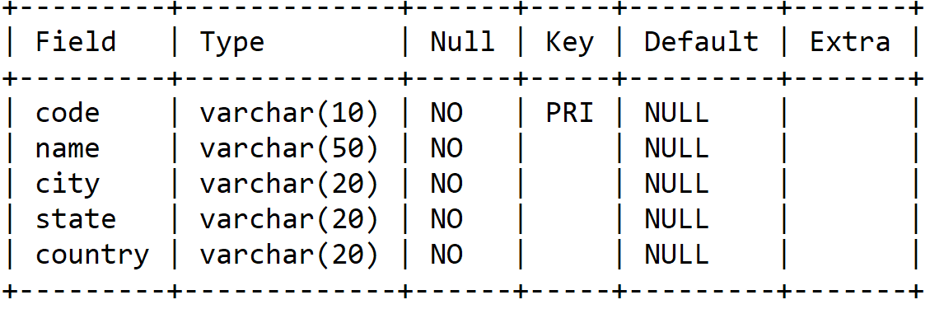

Book:

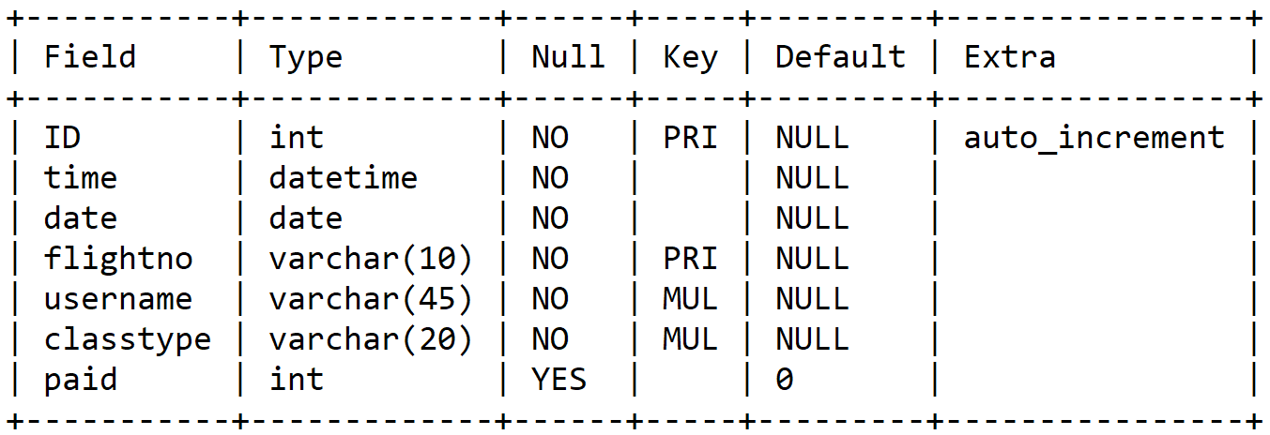

Class:

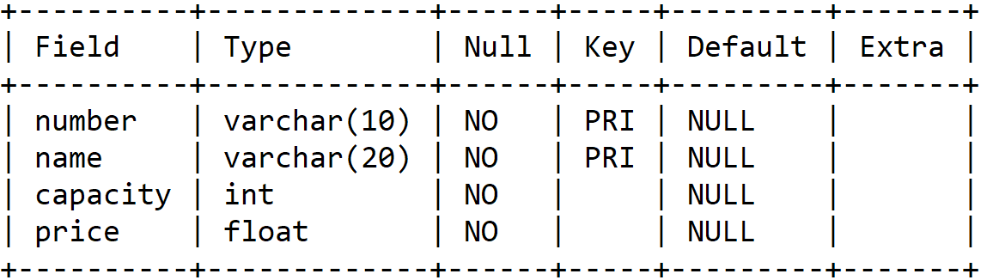

Flight:

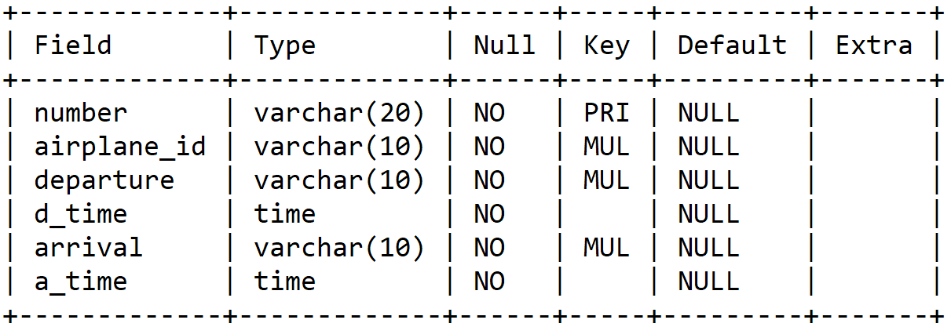

Passenger:

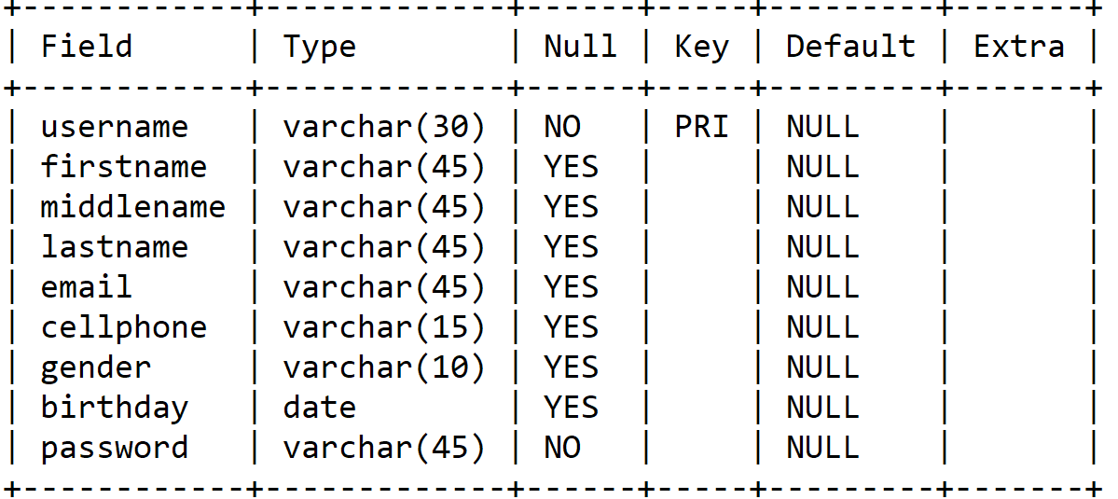

Files include:

Adminadd.php :- This helps the administrator to add new flights

Admindelete.php :- This helps the admin to delete flights.

Adminsearch.php:- Searches the flight using flight number

Adminupdate.php:- Update flight details by the admin

Cancellation.php:- Ticket cancellation by the customer

Cartdelete.php:- Empties your cart

Cartshow.php:- Displays your shopping cart

Checkuser.php:- checks the availability of a user

Dbconncet.php:- connects to xampp server

Homepage.html: homepage of the website

Login.php:- logs in the user/customer

Logout.php: logs out the user/customer

Pay.php: payment complete

Register.php:- register a new customer

Searchresultall.php:- shows all the available flights on that day

Searchresultoneway.php:- All the one-way flights on that day to location

SearchResultRoundTrip.php:- displays all the flights both ways

Shoppingcart.php:- takes you to shopping cart

Showhistory.php:- Diplays your past bookings with an option to cancel.

**Screenshots:**

1. Homepage

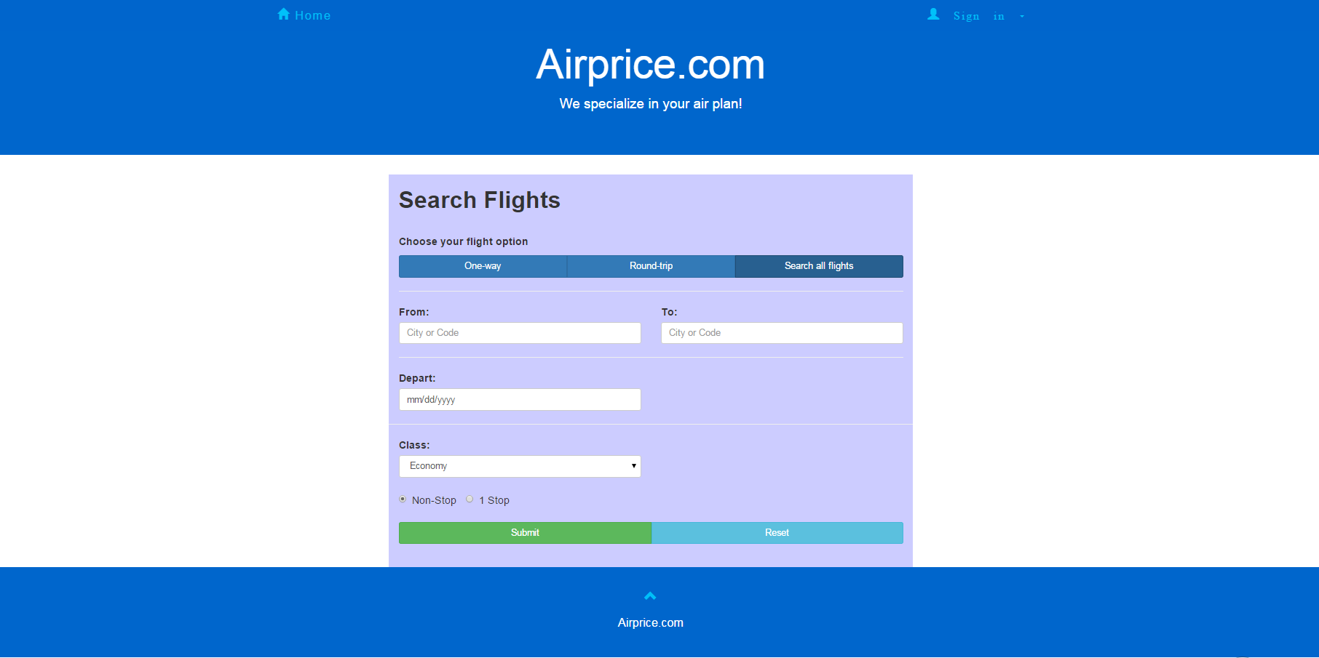

2. Sign up

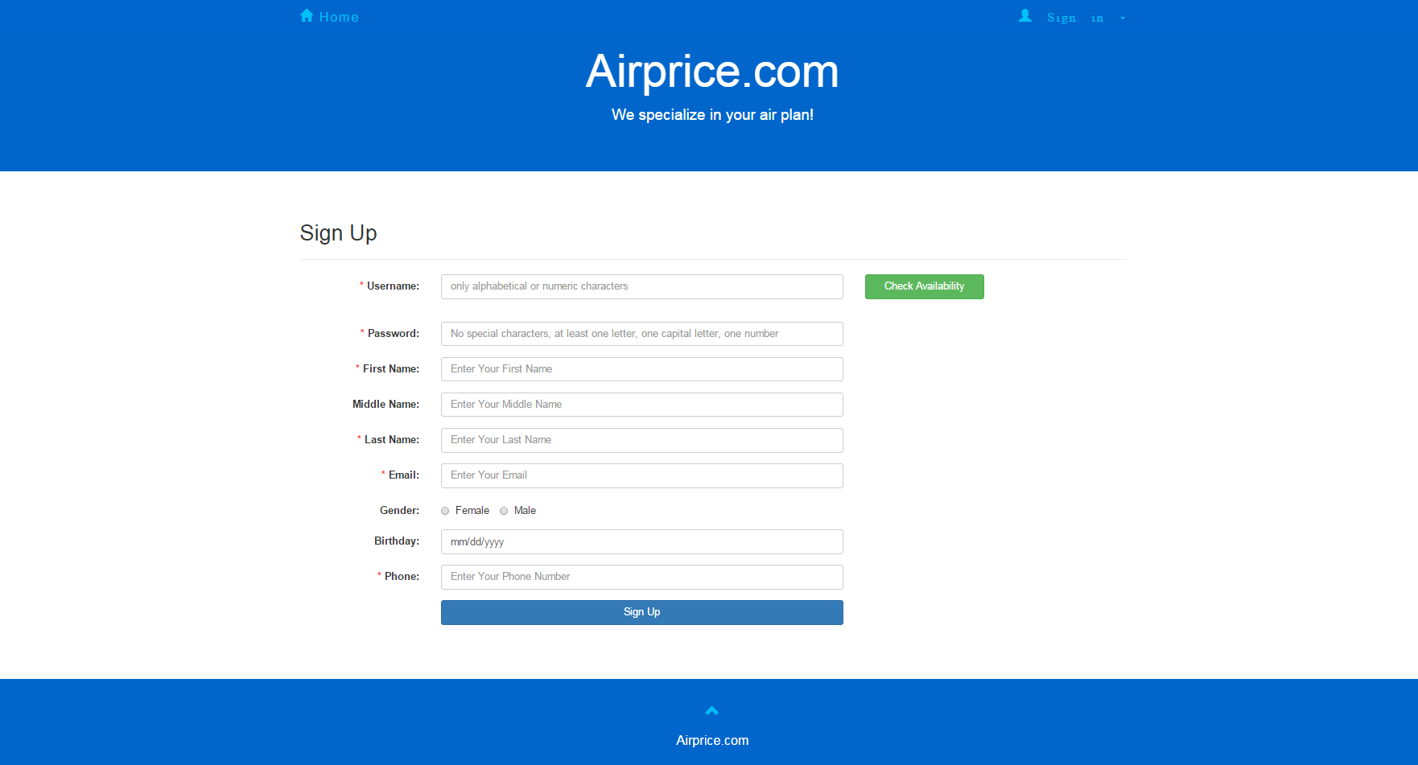

3. Sign in

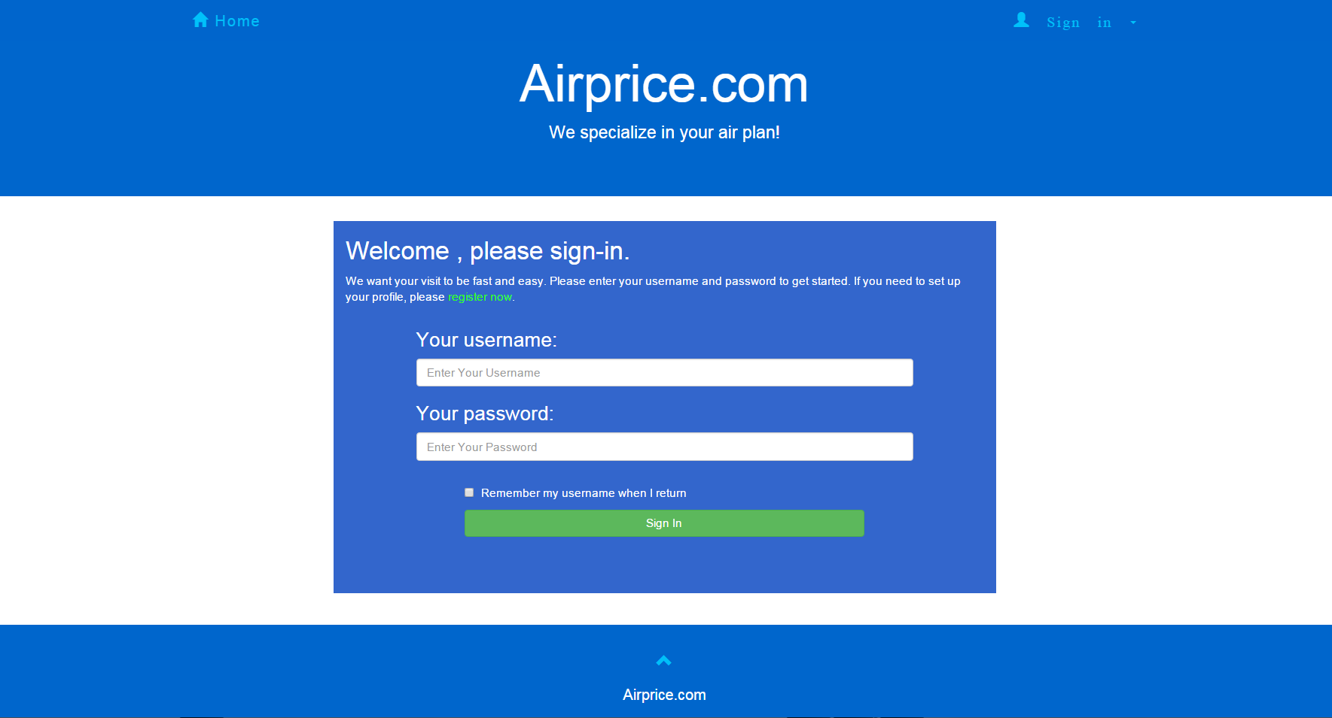

4. Shopping cart

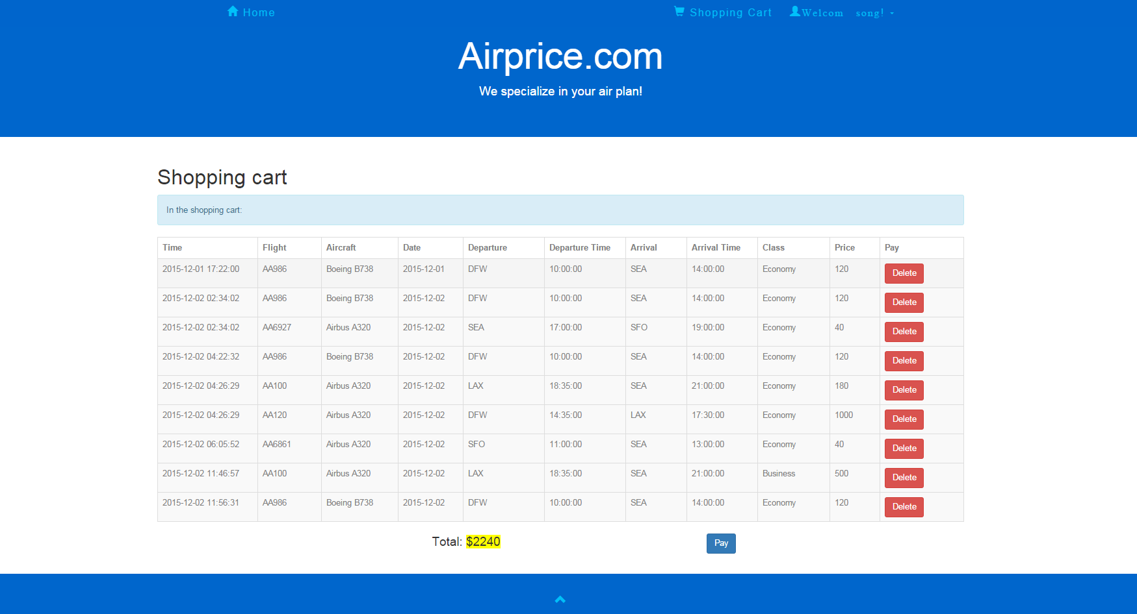

5. History

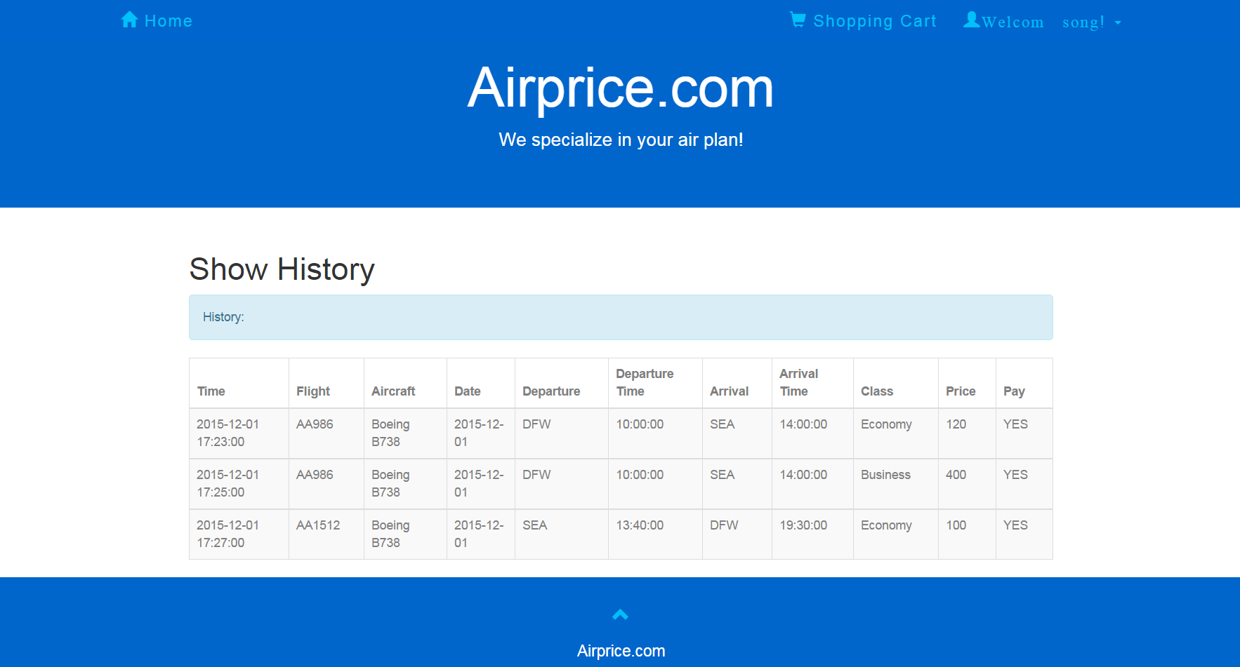

6. Search result

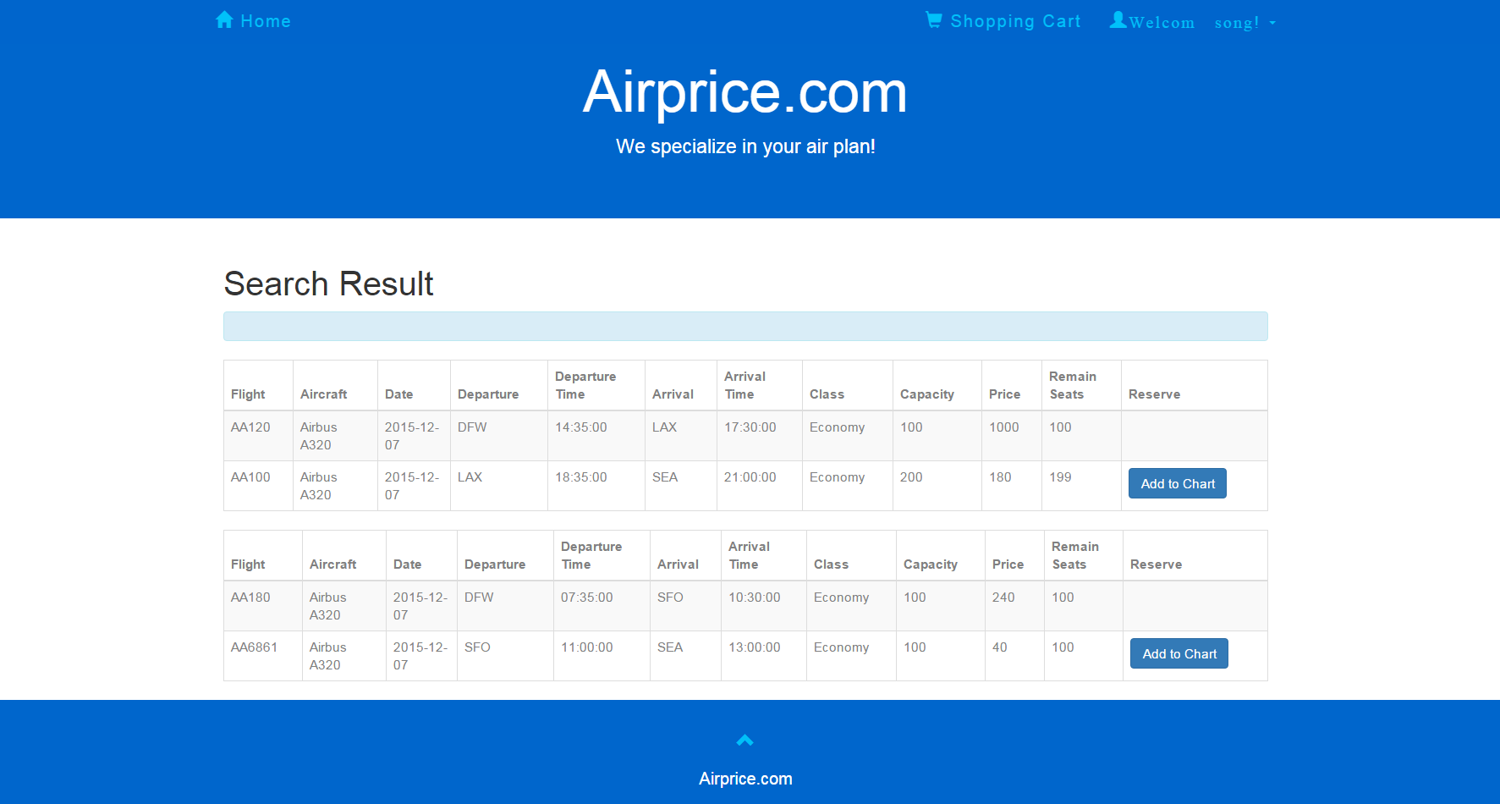

7. Admin page

